Project Development Phase
Model Performance Test

DATE | 26-06-25
TEAM ID | LTVIP2025TMID32045
PROJECT NAME | EDUTUTOR AI:Personalized Learning with Generative AI nad LMS Integration.
MAXIMUM MARKS | 4 MARKS
Model Performance Testing:
Project team shall fill the following information in model performance testing template.
S.No. | Parameter | Values | Screenshot
 | Model Summary | - | 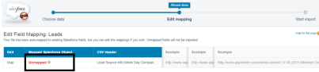
 | Accuracy | Training Accuracy -  Validation Accuracy - | 
3. | Fine Tunning Result( if Done) | Validation Accuracy - | 

